**Project Report**

**On**

**“HOTEL GUEST FEEDBACK MANAGEMENT SYSTEM”**

Submitted for the partial fulfillment of the requirement for the degree of

**Bachelor of Technology**

in

**Computer Science & Engineering**

**By**

**SIRAJ MOHAMMAD Reg. No: 1601287102**

**DAYANULLAH KHAN**  **Reg. No: 1601287056**

**Supervised By**

**Prof. CHINMAYA KUMAR NAYAK**



**GANDHI INSTITUTE FOR TECHNOLOGICAL ADVANCEMENT,**

**BHUBANESWAR**

**MARCH 2020**



**Department of Computer Science & Engineering**

**Gandhi Institute for Technological Advancement, Bhubaneswar**

**CERTIFICATE**

## 



This is to certify that the project work “ Hotel Guest Feedback Management System “ submitted by :

**SIRAJ MOHAMMAD Reg. No: 1601287102**

**DAYANULLAH KHAN**  **Reg. No: 1601287056**

is an authentic work carried out by them at GITA under my guidance. The matter embodied in this work has not been submitted earlier for the award of any degree or to the best of my knowledge and belief .

**Prof. (Dr.) Tarini Prasad Panigrahi Prof. Chinmaya Kumar Nayak**

**( H.O.D., Dept. of CSE ) ( Supervisor )**

**Examined by:**

**(Prof.(Dr.) )**

**(External Examiner)**

**Examined by:**

**(Prof.(Dr.) )**

**(External Examiner)**



**-**

**Department of Computer Science & Engineering**

**Gandhi Institute for Technological Advancement, Bhubaneswar**

**ACKNOWLEDGEMENT**

*I express my deepest sense of gratitude to our beloved professor (Late)****Prof.(Dr.)Manoranjan Pradhan****, Ex-Head of Department, Computer Science & Engineering for his initiative and constant inspiration.*

*I also express and gratitude* ***to Prof. Chinmaya Kumar Nayak****, project supervisor for his guidance and constant support.*

*I also take this opportunity to thank* **Prof. (Dr.) Tarini Prasad Panigrahi,***Head of Department, Computer Science & Engineering, for his constant support and timely advice.*

*Lastly, words run to express my gratitude to all the faculties of the CSE Dept.and friends for their support and co-operation, constructive criticism and valuable suggestion during preparation of this project report.*

*Thanking All…..*

(Full signature of the student ) (Full signature of the student)

**DAYANULLAH KHAN SIRAJ MOHAMMAD**

Reg. No: 1601287056 Reg. No: 1601287102

Email: dayanullahkhan97@gmail.com Email:sirajmohammad286@gmail.

**ABSTRACT**

Hotel guest feedback management system is a web application which provides an easy way to know information about a hotel. In this application, all the information of the hotel will be added by admin. Guests can find all the details of hotel and can give feedback which will be helpful to new guests who are searching for hotel information.

**CONTENTS**

**TOPICS Page No.**

**1. INTRODUCTION 1**

**1.1 Existing System 1**

**1.2 Proposed System 1**

**2. MODULE 2**

**2.1 Admin 2**

**2.2 Guest 2**

**2.3 Fresh Guest 2**

**3. LOGIN DETAILS 3**

**3.1 Admin Login Details 3**

**3.2 Guest Login Details 3**

**3.3 Fresh Guest Login Details 4**

**4. ADVANTAGES 5**

**5. REQUIREMENTS AND SPECIFICATIONS 7**

**6. FLOWCHART 9**

**6.1 What is a flowchart? 9**

**6.2 When to use a flowchart 9**

**6.3 Commonly used symbols in flowcharts 10**

**6.4 Flowchart basic procedure 11**

**6.5 Detailed flowchart 12**

**7. ER DIAGRAM 13**

**8. COLLABORATION DIAGRAM 16**

**8.1 Notations of a collaboration diagram 16**

**8.2 When to use a collaboration diagram 18**

**9. IMPLEMENTATION 20**

**10. DATABASE SCRIPTS 37**

**11. CONCLUSION 41**

**BIBLIOGRAPHY 42**

**CHAPTER 1**

**INTRODUCTION**

Hotel guest feedback management system is a web application which provides an easy way to know information about a hotel. In this application, all the information of the hotel will be added by admin. Guests can find all the details of hotel and can give feedback which will be helpful to new guests who are searching for hotel information.

**1.1 Existing System**

In the existing system,there is no proper information about hotels.Guests who are searching for hotel details should go physically and make enquire about hotel which takes a lot of time and effort.The guest is not able to give feedback about hotel.

**1.2. Proposed System:**

The proposed system provides an easy way to a fresh guest who is searching for hotel information. All the information is added by admin where guests and fresher’s can easily access the information. This system saves a lot of time and effort of guests. This system also provides a chance for guests to give feedback about the hotel.

**CHAPTER 2**

**MODULE**

**2.1. Admin:**

Admin needs to get logged in with valid username and password. Admin can add hotel, add service and view hotel.

**2.2. Guest:**

The guest needs to get registered with the application by entering all the details in the registration page. A guest can get logged in by entering hotel name, username, and password. A guest can view profile, view Hotel, view services and can give feedback.

**2.3. Fresh Guest (new guest):**

Fresh guest can get registered with the application by entering all the details in the registration page. Fresh guest can get logged in by entering hotel name, username, and password. Fresh guest can view profile, view hotel, view placements and view feedback.

**CHAPTER 3**

**LOGIN DETAILS**

**3.1. Admin Login Details**

* Step1: Start
* Step2: Login to the account with a unique username and password
* Step3: Choose from the options
* Add hotel with its link,address and image
* Step-4: Add specific services which are provided by the hotel from a particular date.
* Step-5: After adding the services, he/she can view the hotel which is added by him/her.
* Step-6: Logout

**3.2. Guest Login Details**

* Step1: Start
* Step2: Login to the account with username and password.
* If not registered, register by filling required details.
* Step3: Guest can view his/her profile
* Step4: Confirm the hotel for which he/she is providing the feedback by viewing it once.
* Step5: Confirm the services which are provided by the hotel .
* Step6: Provide the feedback
* Step7:Logout

**3.2. Fresh Guest Login Details**

* Step1: Start
* Step2: Login to the account with username and password.
* If not registered, register by filling required details.
* Step3:Fresh Guest can view his/her profile.
* Step4: Fresh Guest can view hotels.
* Step5: Fresh Guest can also view the feedbacks of different hotels.
* Step6: Logout

**CHAPTER 4**

**ADVANTAGES**

The key features and advantages of online feedback system are listed below:

**1) Cost-efficiency:**

Using this system reduces the cost of paper and in person surveys which are conducted also the administration cost is reduced.

**2) Time saver:**

feedback software saves a lot of time and effort. Through this system, you can quickly generate, collect and examine surveys. Performing all of these functions in one integrated web system saves you a extensive amount of time.

**3) Convenience:**

It is very convenient for users to complete online surveys. Participants can fill out forms when they choose to and start and stop a survey at their ease.

**4) Accessibility:**

Administering your surveys through an online system increases accessibility. Link of the survey can be sent via Gmail or any other social networking platform. Respondents then have a variety of ways to access the forms including mobile phones, laptops, tablets, computers, etc.

**5) Reach & Scalability:**

One of the greatest advantages of using online surveys is the reach and scalability. You can send surveys to thousands of people at the same time you take to send survey to single person. Also you can send surveys across the world and create forms in different languages.

**6) Flexibility:**

Online surveys provide more flexibility in the design. in manual system participants can skip question but here this is not possible since every field is mandatory therefore the form will not get submitted till each and every questions are attempted.

**7) Anonymity:**

here admin also cannot view that which feedback was submitted by which guest. With this feature guest can give honest feedback without disclosing their identity.

**8) More Accurate:**

Since it is computer generated report the calculation error which generally comes in manual is reduced and hence providing you with more accurate reports.

**9) Results:**

As soon as guest has completed the form, a new guest can view and analyze the reports. Through an online hotel guest feedback management system, data can be presented in specific order.

**CHAPTER 5**

**REQUIREMENTS AND SPECIFIACTIONS**

**A. Functional Requirements**

* The system should be giving minimal and relevant data only to the users.
* Digital storage of data should be secure, always available and persistent.
* Admin manages the overall feedback system.
* Guests can register and provides feedback.
* Admin can access the feedback given by the guests.

**B. Non-Functional Requirement**

* Cost of storage and maintenance should be affordable.
* Ease of use should be high.
* Portability: It is portable because it can be used both in Linux and Windows Operating System.
* Reliability: Accurate feedback is provided.
* Availability: The portal should be available for any number of systems.
* Security: Authenticated guests can fill the feedback.

**C. Minimum Hardware Requirements**

* Processor : Pentium IV and above
* Hard Disk : 250 GB
* RAM :1GB
* Keyboard
* Mouse

**D. Software Requirements**

* Server Operating System: Linux /windows server(Windows 10)
* Web server: Apache 9.0
* Database Server: MySQL
* Client Operating System: Linux Desktop/Windows Desktop OS
* Client Browser Requirement: IE7, Firefox 23, Chrome etc.

# CHAPTER 6

# FLOWCHART

# 6.1. WHAT IS A FLOWCHART?

Also called: process flowchart, process flow diagram.

Variations: macro flowchart, top-down flowchart, detailed flowchart (also called process map, micro map, service map, or symbolic flowchart), deployment flowchart (also called down-across or cross-functional flowchart), several-leveled flowchart.

A flowchart is a picture of the separate steps of a process in sequential order. It is a generic tool that can be adapted for a wide variety of purposes, and can be used to describe various processes, such as a manufacturing process, an administrative or service process, or a project plan. It's a common [process analysis tool](https://asq.org/quality-resources/process-analysis-tools) and one of the [seven basic quality tools](https://asq.org/quality-resources/seven-basic-quality-tools).   
  
Elements that may be included in a flowchart are a sequence of actions, materials or services entering or leaving the process (inputs and outputs), decisions that must be made, people who become involved, time involved at each step, and/or process measurements.

## 6.2. WHEN TO USE A FLOWCHART

* To develop understanding of how a process is done
* To study a process for improvement
* To communicate to others how a process is done
* When better communication is needed between people involved with the same process
* To document a process
* When planning a project

## 6.3. COMMONLY USED SYMBOLS IN FLOWCHARTS

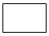One step in the **process**. The step is written inside the box. Usually, only one arrow goes out of the box.

 **Direction** of flow from one step or decision to another.

 **Decision** based on a question. The question is written in the diamond. More than one arrow goes out of the diamond, each one showing the direction the process takes for a given answer to the question. (Often the answers are "yes" and "no.")

**Delay or wait**

**Link** to another page or another flowchart. The same symbol on the other page indicates that the flow continues there.

**Input or output**

**Document**

Alternate symbols for **start** and **end** points

## 6.4. FLOWCHART BASIC PROCEDURE

**Materials needed:** Sticky notes or cards, a large piece of flipchart paper or newsprint, and marking pens.

1. Define the process to be diagrammed. Write its title at the top of the work surface.
2. Discuss and decide on the boundaries of your process: Where or when does the process start? Where or when does it end? Discuss and decide on the level of detail to be included in the diagram.
3. Brainstorm the activities that take place. Write each on a card or sticky note.
4. Arrange the activities in proper sequence.
5. When all activities are included and everyone agrees that the sequence is correct, draw arrows to show the flow of the process.
6. Review the flowchart with others involved in the process (workers, supervisors, suppliers, customers) to see if they agree that the process is drawn accurately.

**6.5. DETAILED FLOWCHART**

START

NO

If registered

Registration

admin

**Yes**

LOGIN

**No**

IS VALID ?

IS FRESH GUEST

VIEW HIS/HER PROFILE

VIEW THE HOTELS

VIEW FEEDBACK

IS ADMIN

VIEW THE HOTELS

IS GUEST

ADD HOTEL

VIEW HIS/HER PROFILE

ADD SERVICES

VIEW THE HOTELS

VIEW SERVICES

PROVIDE FEEDBACK

LOG OUT

STOP

**CHAPTER 7**

**ER DIAGRAM**

An entity-relationship diagram (ERD) is a data modeling technique that graphically illustrates an information system’s entities and the relationships between those entities. An ERD is a conceptual and representational model of data used to represent the entity framework infrastructure.

The elements of an ERD are:

* Entities
* Relationships
* Attributes

Steps involved in creating an ERD include:

1. Identifying and defining the entities
2. Determining all interactions between the entities
3. Analyzing the nature of interactions/determining the cardinality of the relationships
4. Creating the ERD

An entity-relationship diagram (ERD) is crucial to creating a good database design. It is used as a high-level logical data model, which is useful in developing a conceptual design for databases.

An entity is a real-world item or concept that exists on its own. Entities are equivalent to database tables in a relational database, with each row of the table representing an instance of that entity.

An attribute of an entity is a particular property that describes the entity. A relationship is the association that describes the interaction between entities. Cardinality, in the context of ERD, is the number of instances of one entity that can, or must, be associated with each instance of another entity. In general, there may be one-to-one, one-to-many, or many-to-many relationships.

For example, let us consider two real-world entities, an employee and his department. An employee has attributes such as an employee number, name, department number, etc. Similarly, department number and name can be defined as attributes of a department. A department can interact with many employees, but an employee can belong to only one department, hence there can be a one-to-many relationship, defined between department and employee.

In the actual database, the employee table will have department number as a foreign key, referencing from department table, to enforce the relationship.

hotelname

gives

FEEDBACK

GUEST

view only registered

views

views

HOTEL

FRESHER

views

Add/update/views

Add/update/views

ADMIN

SERVICES

**CHAPTER 8**

**COLLABORATION DIAGRAM**

A collaboration diagram, also known as a communication diagram, is an illustration of the relationships and interactions among software [objects](https://searchmicroservices.techtarget.com/definition/object) in the Unified Modeling Language ([UML](https://searchsoftwarequality.techtarget.com/definition/Unified-Modeling-Language)). These diagrams can be used to portray the dynamic behavior of a particular [use case](https://searchsoftwarequality.techtarget.com/definition/use-case/) and define the role of each object.

Collaboration diagrams are created by first identifying the structural elements required to carry out the functionality of an interaction. A model is then built using the relationships between those elements. Several vendors offer software for creating and editing collaboration diagrams.

**8.1. Notations of a collaboration diagram**

A collaboration diagram resembles a [flowchart](https://whatis.techtarget.com/definition/flowchart) that portrays the roles, functionality and behavior of individual objects as well as the overall operation of the system in [real time](https://whatis.techtarget.com/definition/real-time). The four major components of a collaboration diagram are:

1. Objects- Objects are shown as rectangles with naming labels inside. The naming label follows the convention of object name: class name. If an object has a property or state that specifically influences the collaboration, this should also be noted.
2. Actors- Actors are instances that invoke the interaction in the diagram. Each actor has a name and a role, with one actor initiating the entire use case.
3. Links- Links connect objects with actors and are depicted using a solid line between two elements. Each link is an instance where messages can be sent.
4. [Messages](https://whatis.techtarget.com/definition/message)- Messages between objects are shown as a labeled arrow placed near a link. These messages are communications between objects that convey information about the activity and can include the sequence number.

The most important objects are placed in the center of the diagram, with all other participating objects branching off. After all objects are placed, links and messages should be added in between.

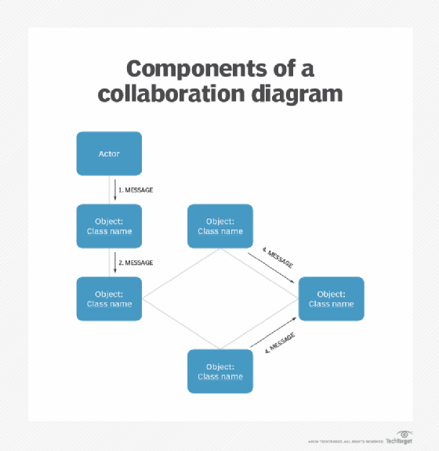

Components of a collaboration diagram

**8.2. When to use a collaboration diagram**

Collaboration diagrams should be used when the relationships among objects are crucial to display. A few examples of instances where collaboration diagrams might be helpful include:

* Modeling collaborations, mechanisms or the structural organization within a system design.
* Providing an overview of collaborating objects within an object-oriented system.
* Exhibiting many alternative scenarios for the same use case.
* Demonstrating forward and [reverse engineering](https://searchsoftwarequality.techtarget.com/definition/reverse-engineering).
* Capturing the passage of information between objects.
* Visualizing the complex logic behind an operation.

However, collaboration diagrams are best suited to the portrayal of simple interactions among relatively small numbers of objects. As the number of objects and messages grows, a collaboration diagram can become difficult to read and use efficiently. Additionally, collaboration diagrams typically exclude descriptive information, such as timing.

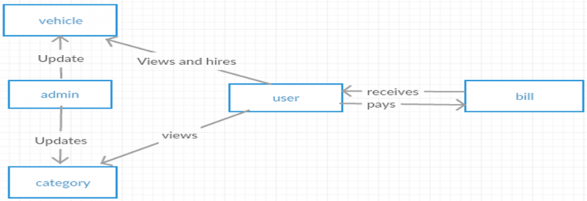

**CHAPTER 9**

**IMPLEMENTATION**

**i) Home page:**

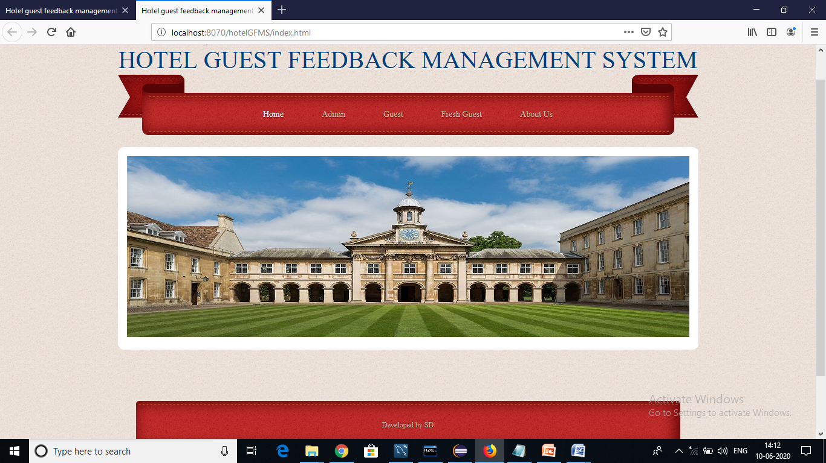

This is the home page of the project “Hotel guest feedback management system” obtained through by running “index.html” file on the server.

**ii) Admin login page:**

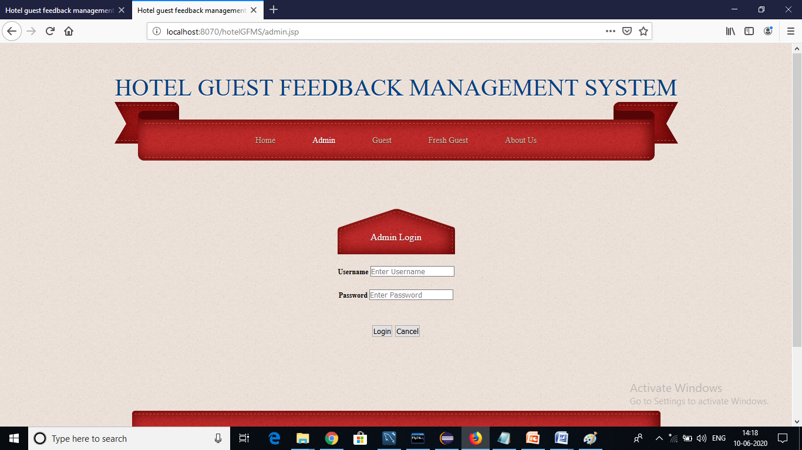

This is the admin login page of our project “Hotel guest feedback management system” obtained through by running “admin.jsp” file on the server.

**iii) Admin home page:**

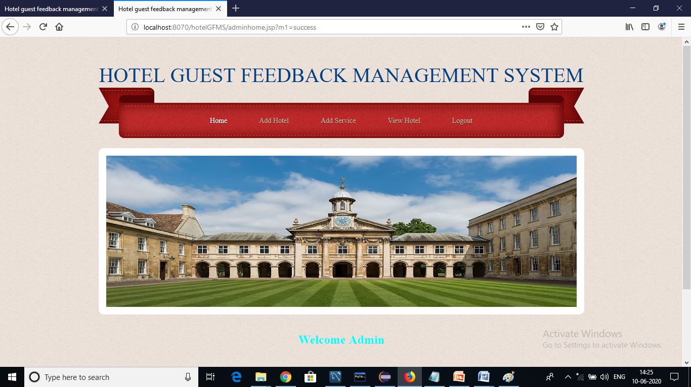

In admin login page admin has to provide username as “admin” and password as “admin” in order to go on admin home page as per the coding done in “adminact.jsp” page.

This is the admin home page of our project “Hotel guest feedback management system” obtained through by running the “adminhome.jsp” page on the server.

**iv) Add hotel page:**

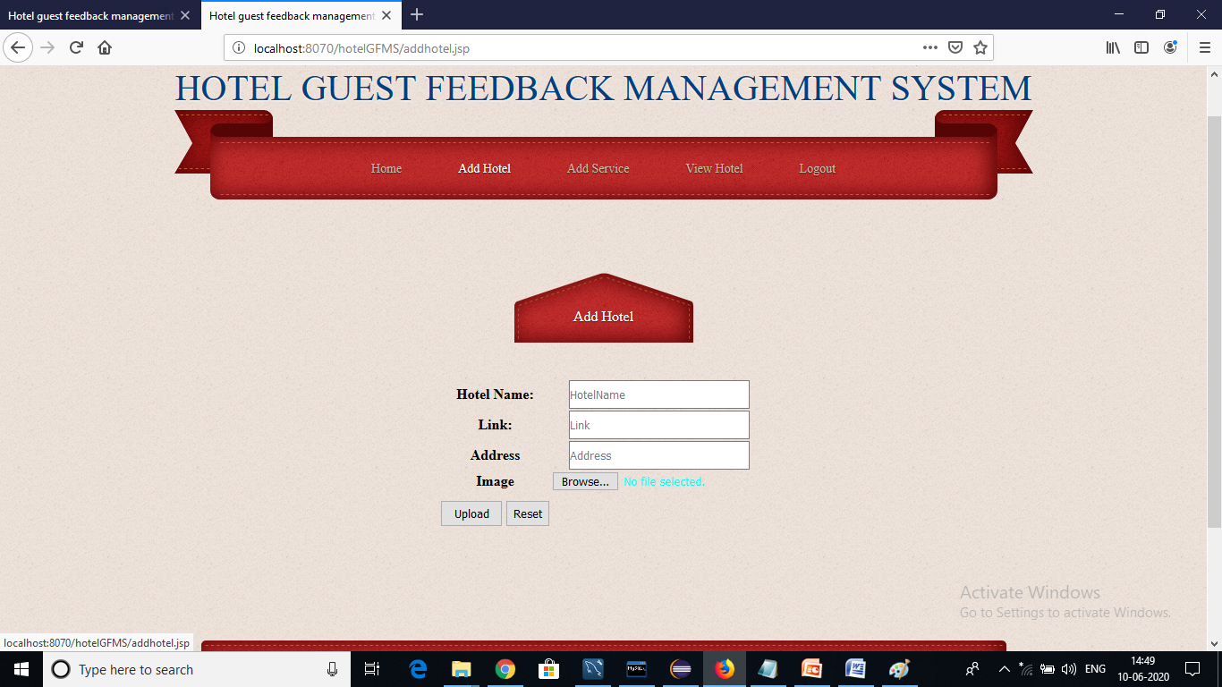

This is the Add hotel page of our project “Hotel guest feedback management system” obtained through by running “addhotel.jsp” on the server where admin has to provide the following details:-

* Hotel Name
* Link (website link of that hotel)
* Address( location of that hotel)
* Image ( photo of any area of that hotel if it is present)

Then he/she have to click on upload button which will upload that information on server through “addhotelact.jsp” page and save it in the table called “hotel”.

**v) Add service page:**

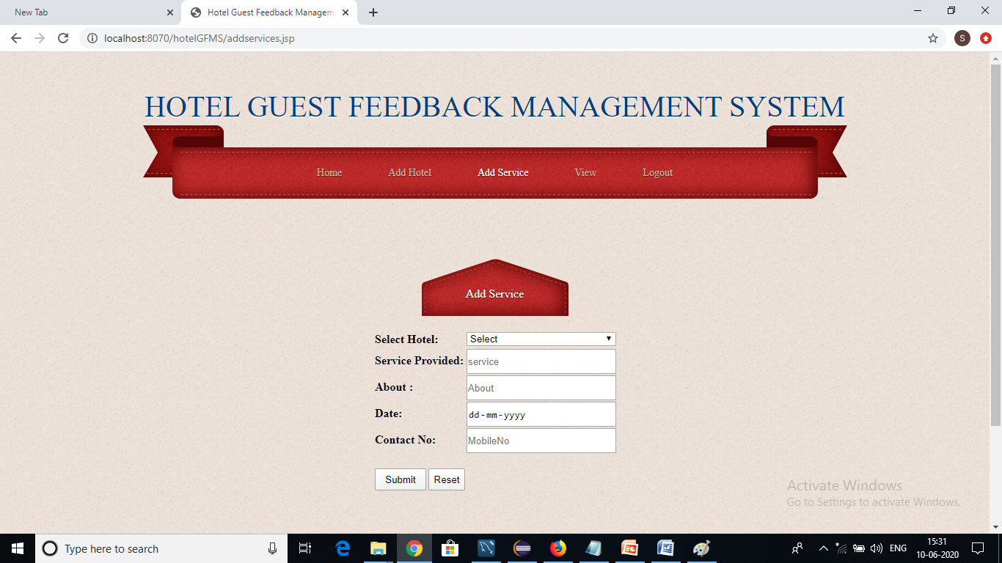

This is the add service page of our project “Hotel guest feedback management system” obtained through by running “addservices.jsp” page on the server after adding the hotel.

In this page admin has to select the desired hotel what he/she has recently added and then he/she has to provide the following details:-

* Service Provided
* About( information related to service what have been provided)
* Date( on which date that service has been provided)
* Contact No.( contact no. of that desired hotel)

After providing all details he/she has to click on submit button which will save all the information provided related to that hotel services in the table called “services” through the running of “addservicesact.jsp” page on the server.

**vi) Guest login page:**

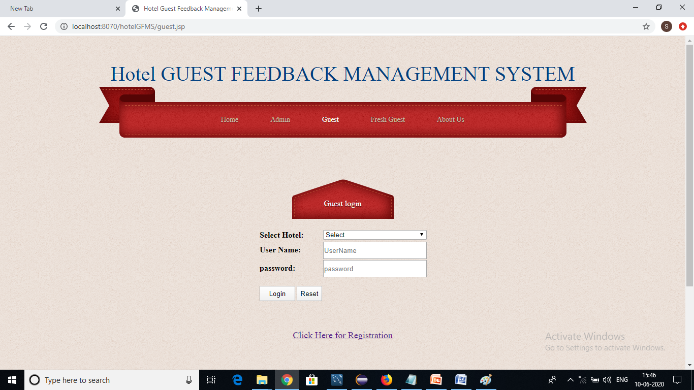

This is the guest login page of our project “Hotel guest feedback Mangement system” obtained through by running “guest.jsp” page on the server.

From this page existing user(guest) can login to the system and if he/she is new to the system then he/she should opt the “Click Here for Registration” link in order to make a new registration.

**vii) Guest registration page:**

This is the guest registration page of our project “Hotel guest feedback Mangement system” obtained through by running “guestreg.jsp” page on the server.

In this page the guest which is new to the system after visiting a hotel can make a fresh registration in order to provide information(feedback) related to that hotel.

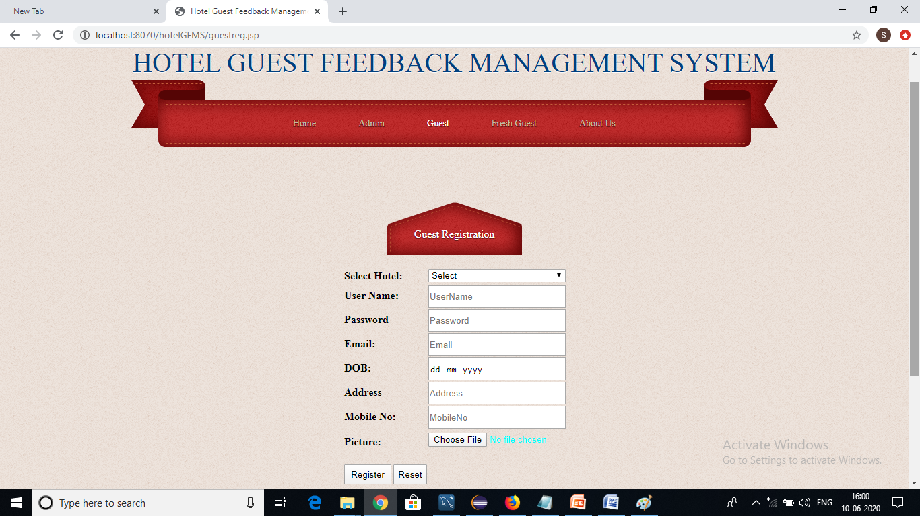

In order to make a fresh registration he/she need to provide the following details.:-

* User Name( username as per the guest desire)
* Password( as per his/her concern)
* Email( email of that guest )
* DOB( date of birth of that guest)
* Address( address of that guest)
* Mobile No.(mobile no. of that guest)
* Picture( image of that guest)

After providing these much of details he/she has to click on register which ultimately save the data in “guest” table through the running of “guestregact.jsp” page on the server.

**viii) Guest home page:**

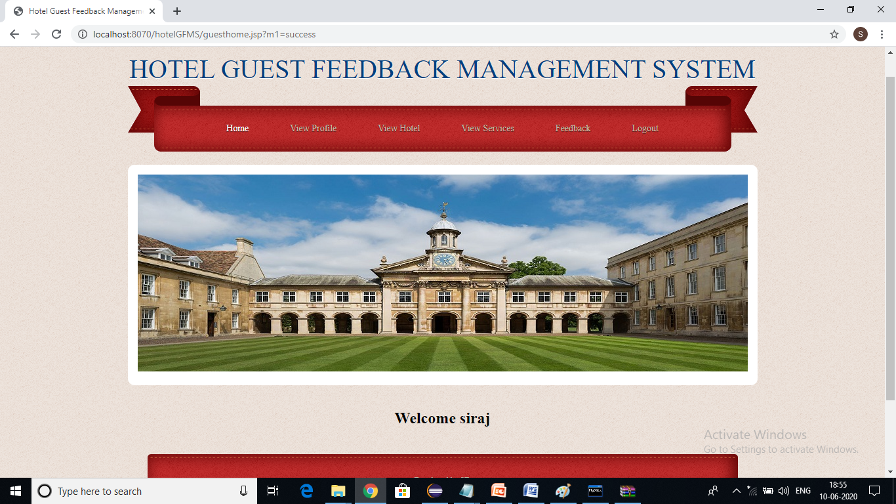

This is the guest home page of our project “Hotel guest feedback Mangement system” obtained through by running “guesthome.jsp” page on the server.

After successful login of a guest to this system this page will appear where he/she can do the following activities:-

* View Profile( he/she can view his/her profile)
* View Hotel( he/she can view the registered hotel which is done by him/her
* View Services( he/she can view the services provided by that registered hotel)
* Feedback( he/she has the authority to provide the feedback regarding the registered hotel)

After providing these much of details he/she can come out to home page of the system by clicking on “Logout”.

**ix) View profile page(guest):**

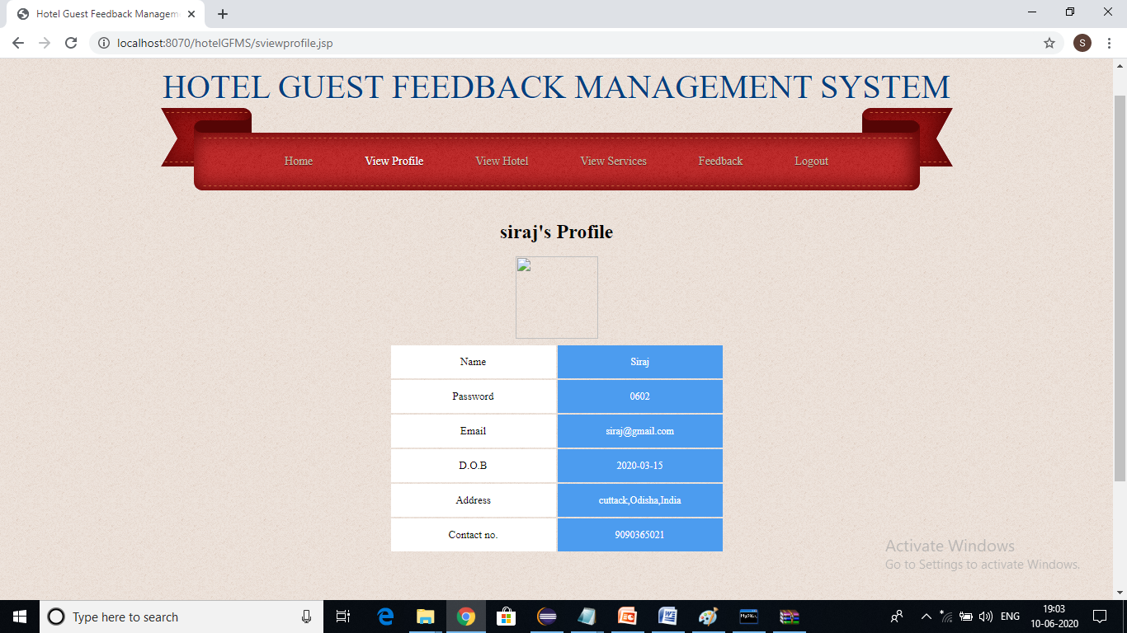

This is the view profile page of our project “Hotel guest feedback Mangement system” obtained through by running “sviewprofile.jsp” page on the server.

In this page ,the information related to guest who log in will appear.

The following will appear as follows:-

* Name of the guest who logged in
* Password of that guest
* Email of that guest
* D.O.B of that guest
* Address of that guest
* Contact no. of that guest

**x) View hotel page(guest):**

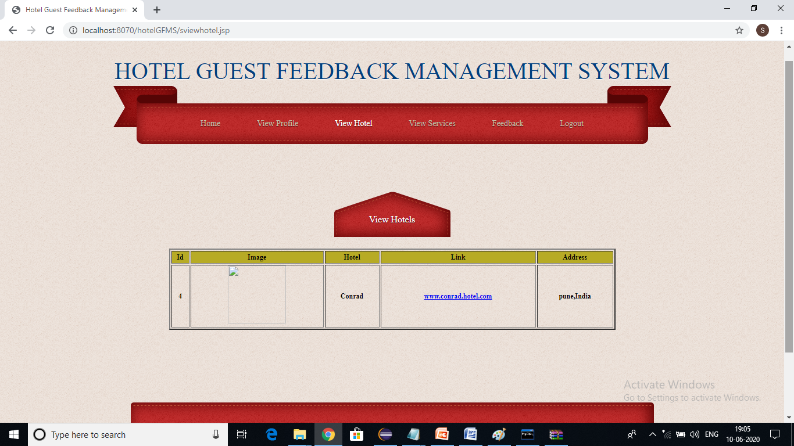

This is the view hotel page of our project “Hotel guest feedback Mangement system” obtained through by running “sviewhotel.jsp” page on the server.

In this page guest can able to view how many hotels he/she has already visited or registered in this system.

**xi) View services page(guest):**

This is the view services page of our project “Hotel guest feedback Mangement system” obtained through by running “sviewservices.jsp” page on the server.

In this page guest can able to see what are the services associated with that registered hotel.

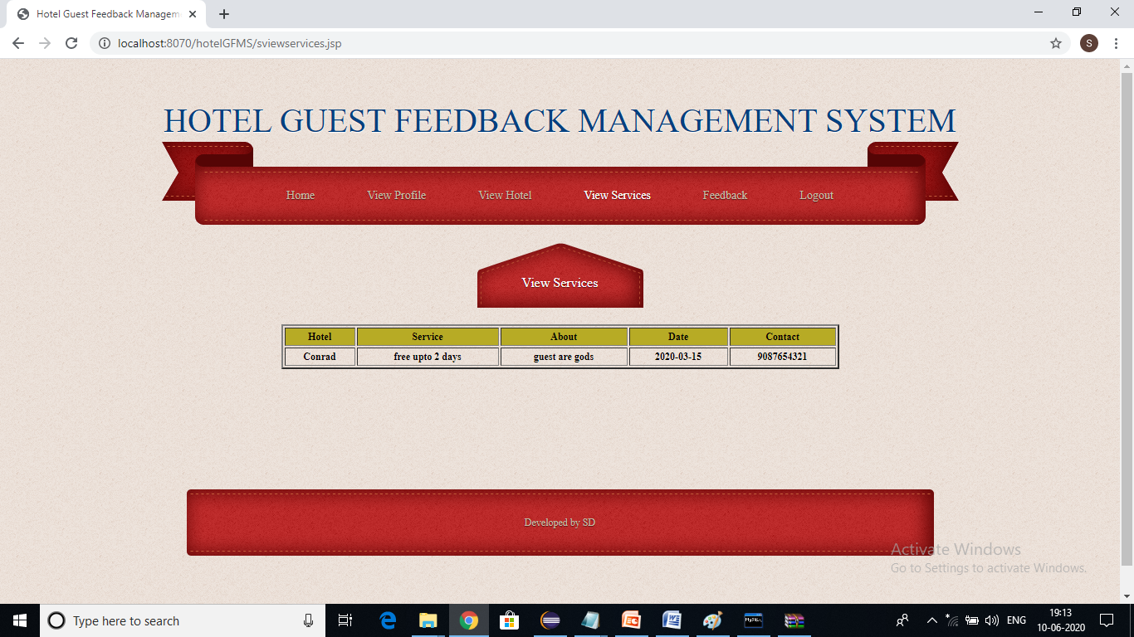

**xii) Feedback page:**

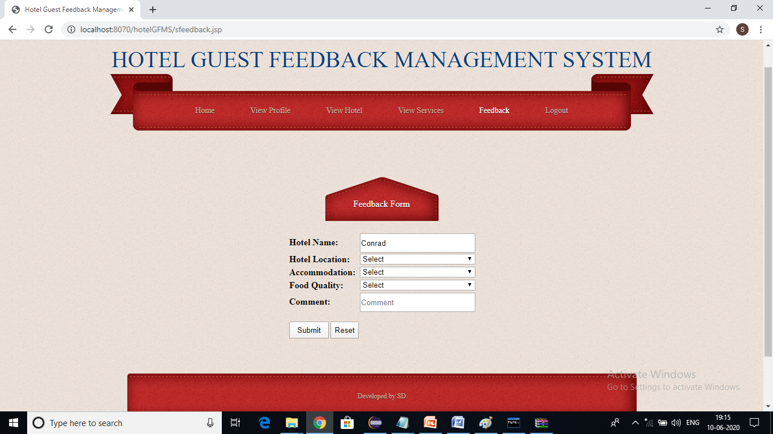

This is the feedback page of our project “Hotel guest feedback Mangement system” obtained through by running “sfeedback.jsp” page on the server.

In this page feedback form is available for the guest who logged in.He/She has to select the desired registered hotel for which he/she want to provide feedback.

After selecting the desired hotel he/she has to rate the following out of five:-

* Hotel location
* Accomodation
* Food Quality
* Comments

After rating all these parameters he/she has to click on submit in order to save all these details in the table called “feedback” through the running of the “sfeedbackact.jsp” page on the server.

**xiii) Fresh guest Login page:**

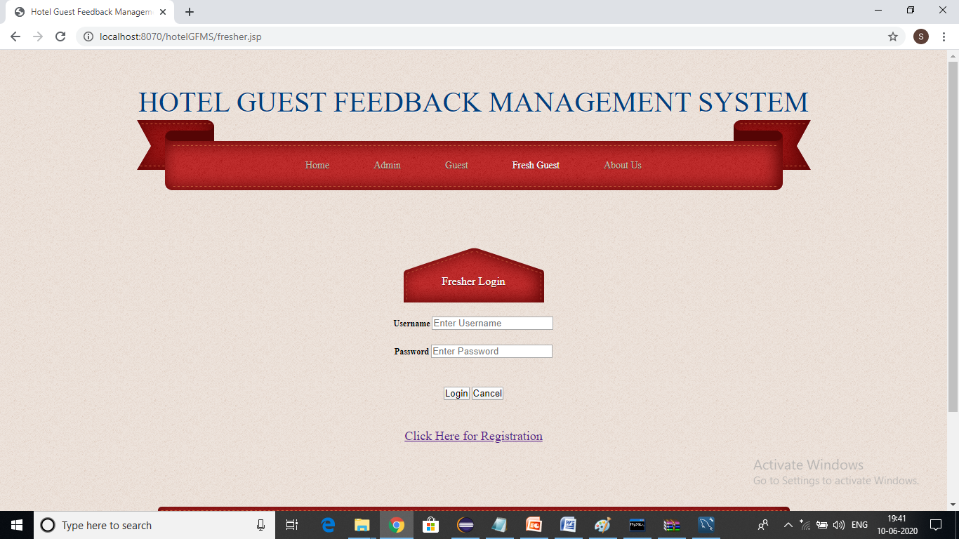

This is the fresh guest login page of our project “Hotel guest feedback Mangement system” obtained through by running “fresher.jsp” page on the server.

From this page existing user( fresh guest) can login to the system and if he/she is new to the system then he/she should opt the “Click Here for Registration” link in order to make a new registration.

**xiv) Fresh guest Registration page:**

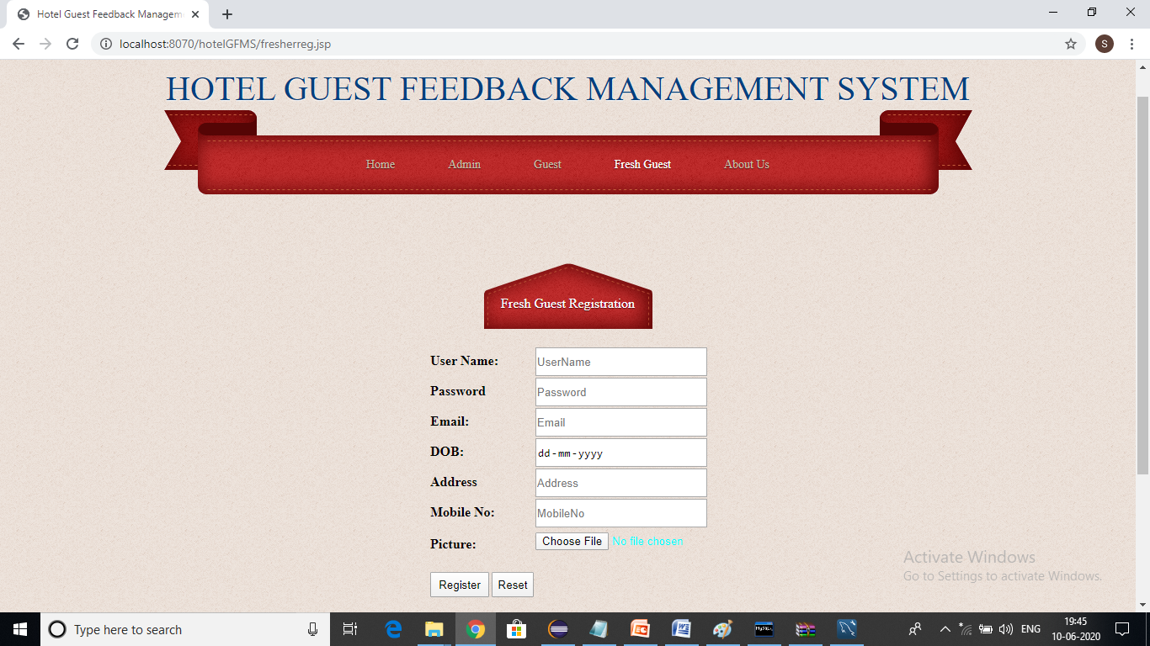

This is the fresh guest registration page of our project “Hotel guest feedback Mangement system” obtained through by running “fresherreg.jsp” page on the server.

In this page the guest which is new to the system want to visit a hotel can make a fresh registration in order to view information(feedback) related to that hotel.

**xv) Fresh guest home page:**

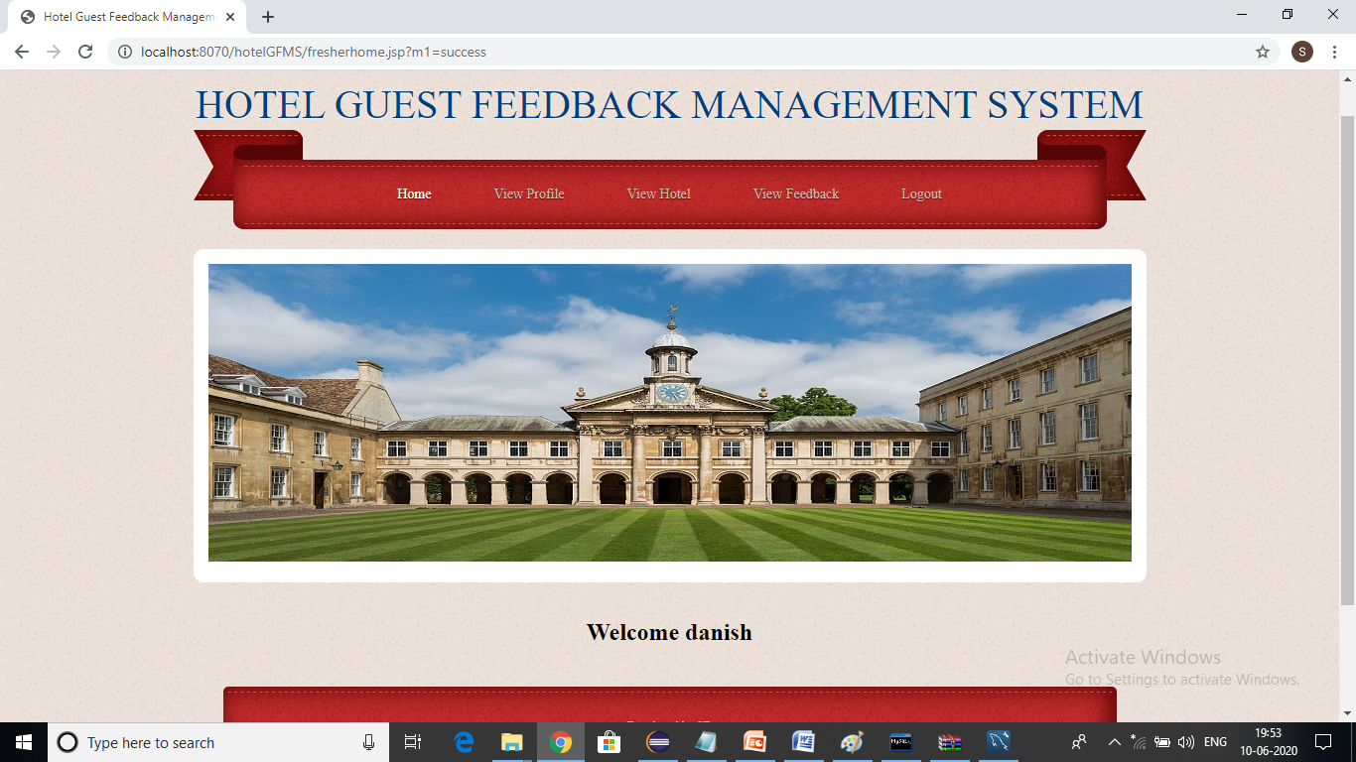

This is the fresh guest home page of our project “Hotel guest feedback Mangement system” obtained through by running “fresherhome.jsp” page on the server.

After successful login of a fresh guest to this system this page will appear where he/she can do the following activities:-

* View Profile( he/she can view his/her profile)
* View Hotel( he/she can view the all the registered hotel which has been done by the guest who already visited that hotel)
* View Feedback( he/she has the authority to view the feedback regarding the registered hotel)

After viewing these much of details he/she can come out to home page of the system by clicking on “Logout” and can able to make a decision where he/she needed to visit.

**xvi) View profile page(fresh guest):**

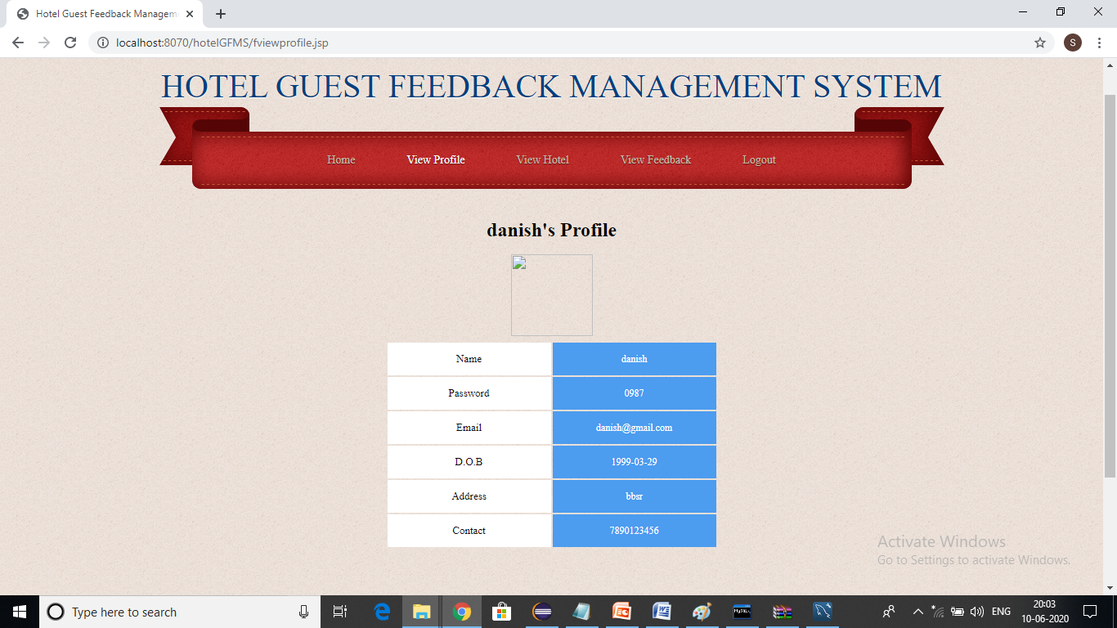

This is the view profile page of our project “Hotel guest feedback Mangement system” obtained through by running “fviewprofile.jsp” page on the server.

In this page ,the information related to fresh guest who log in will appear.

The following will appear as follows:-

* Name of the guest who logged in
* Password of that guest
* Email of that guest
* D.O.B of that guest
* Address of that guest
* Contact no. of that guest

**xvii) View hotel page(fresh guest):**

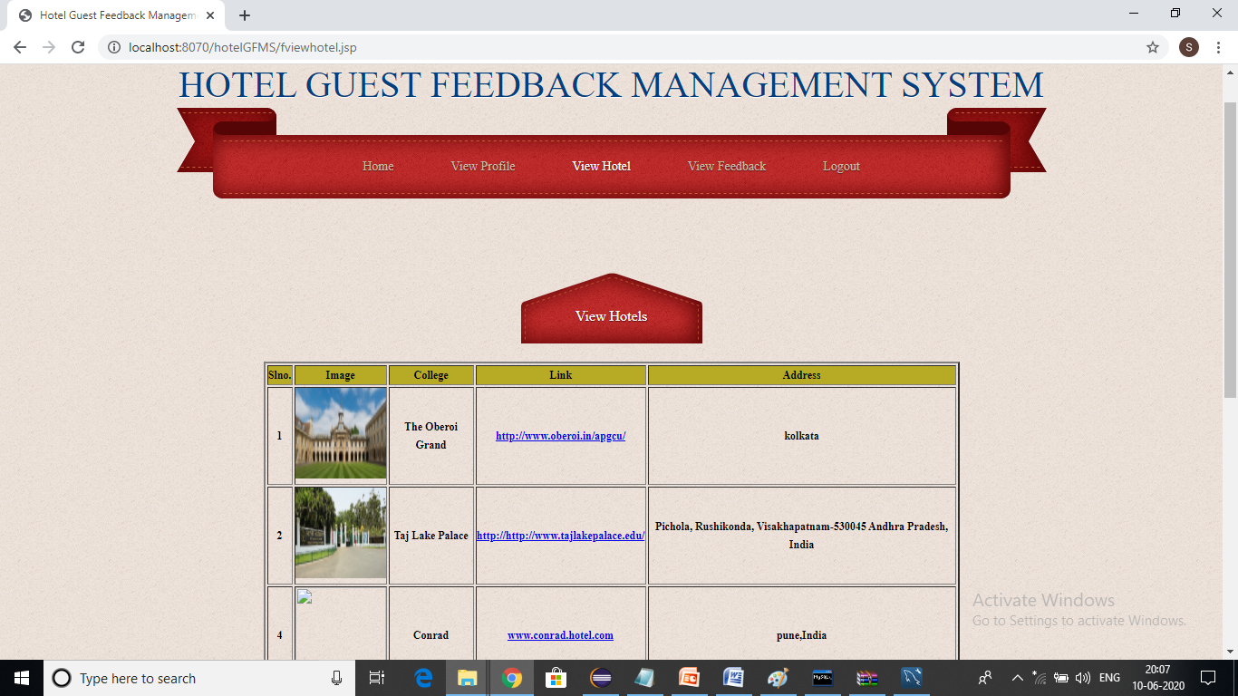

This is the view hotel page of our project “Hotel guest feedback Mangement system” obtained through by running “fviewhotel.jsp” page on the server.

In this page fresh guest can able to view how many hotels visited guest has already registered in this system with their desired information.

**xviii) View feedback page:**

This is the view feedback page of our project “Hotel guest feedback Mangement system” obtained through by running “fviewfeedback.jsp” page on the server.

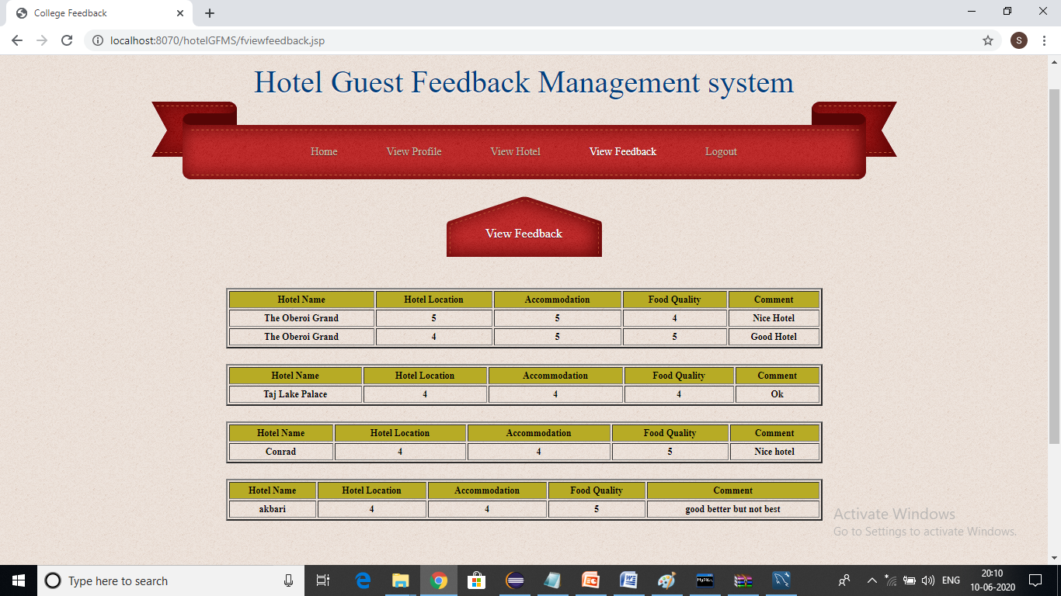

In this page feedback of different hotels are available for the fresh guest who logged in.He/She has to select the desired registered hotel for which he/she want to visit based on feedback provided by the old guest.

he/she has to select based on the following parameters which is rated out of five by the old guests or visited guest:-

* Hotel location
* Accomodation
* Food Quality
* Comments

**xix) About us page:**

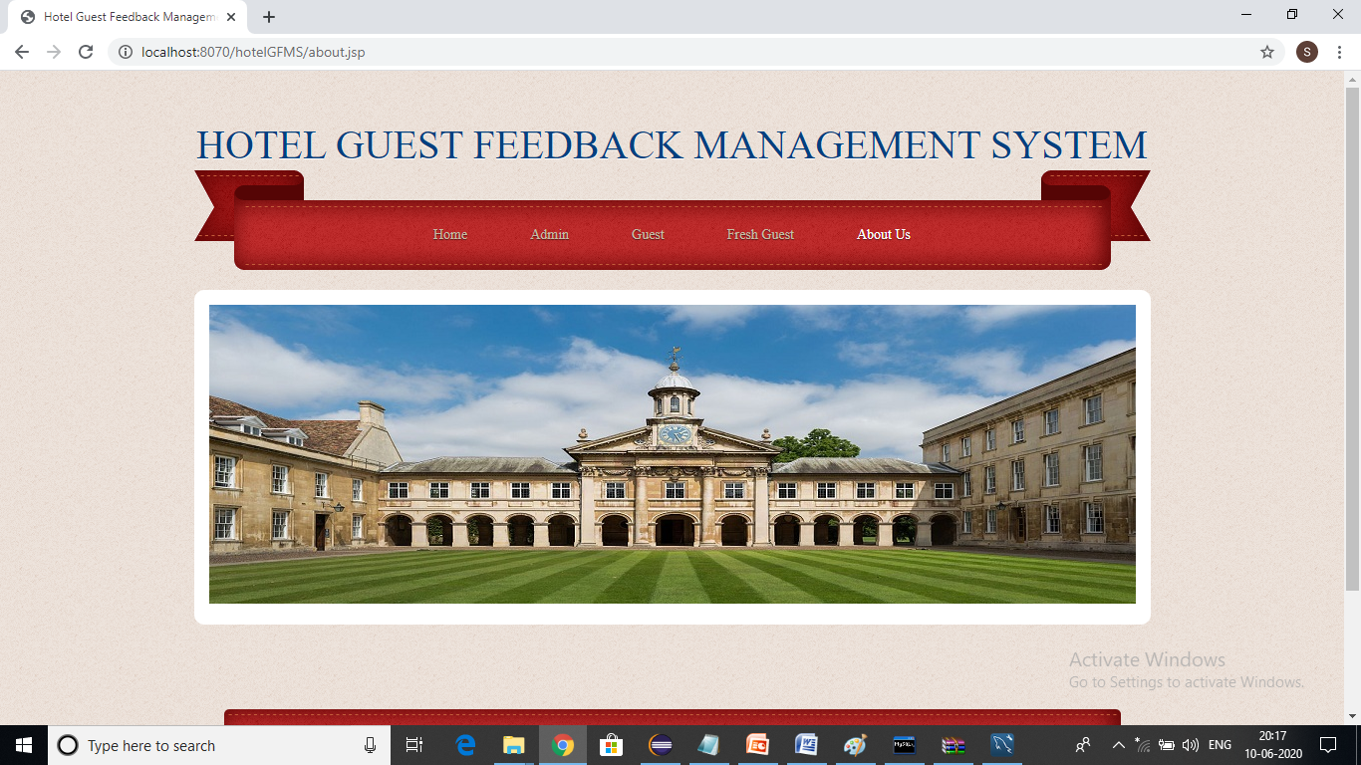

This is the about us page of our project “Hotel guest feedback Mangement system” obtained through by running “about.jsp” page on the server.

This page contains the information regarding the whole system ,FAQs and many more suggestion which have been provided by the user.

**CHAPTER 10**

**DATABASE SCRIPTS**

The Database Scripts project is a series of command line scripts which will dump, erase, restore and merge databases. They are specifically set up to work the best when developing within a version control environment. The primary goals are to:

* keep the database **in sync with code**
* preserve ability to **use the web GUI**
* enable a **rapid** development workflow
* **Merge** development and production databases

**Note:-** Database used as “hm”.

**Hotel Table**

CREATE TABLE `hotel` (

`id` int(100) NOT NULL AUTO_INCREMENT,

`hotelname` varchar(100) DEFAULT NULL,

`link` varchar(100) DEFAULT NULL,

`address` varchar(100) DEFAULT NULL,

`image` varchar(100) DEFAULT NULL,

PRIMARY KEY (`id`)

);

**Services Table**

CREATE TABLE `services` (

`hotelname` varchar(100) DEFAULT NULL,

`service` varchar(100) DEFAULT NULL,

`about` varchar(100) DEFAULT NULL,

`date` date DEFAULT NULL,

`cno` varchar(100) DEFAULT NULL);

**Fresher Table**

CREATE TABLE `fresher` (

`uid` int(11) NOT NULL AUTO_INCREMENT,

` `username` varchar(20) DEFAULT NULL,

`password` varchar(20) DEFAULT NULL,

`email` varchar(40) DEFAULT NULL,

`dob` date DEFAULT NULL,

`address` varchar(50) DEFAULT NULL,

`cno` varchar(20) DEFAULT NULL,

`image` varchar(100) DEFAULT NULL,

PRIMARY KEY (`uid`));

**Guest Table**

CREATE TABLE `guest` (

`uid` int(11) NOT NULL AUTO_INCREMENT,

`hotelname` varchar(100) DEFAULT NULL,

`username` varchar(20) DEFAULT NULL,

`password` varchar(20) DEFAULT NULL,

`email` varchar(40) DEFAULT NULL,

`dob` date DEFAULT NULL,

`address` varchar(50) DEFAULT NULL,

`cno` varchar(20) DEFAULT NULL,

`image` varchar(100) DEFAULT NULL,

PRIMARY KEY (`uid`));

**Feedback Table**

CREATE TABLE `feedback` (

`hotelname` varchar(100) DEFAULT NULL,

`hlocation` int(100) DEFAULT NULL,

`accommodation` int(100) DEFAULT NULL,

`services` int(100) DEFAULT NULL,

`cmnt` varchar(100) DEFAULT NULL

);

**CHAPTER 11**

**CONCLUSION**

Guest can give the feedback to their respective hotels where he/she had visited and results are displayed in the form of scores(generally out of 5). The fresh guest/new guest can view these feedback given for the services handled by them. The admin can add the hotels with their respective services as a result of handling the hotel details. Admin can view all the hotels.

The project “Hotel Guest Feedback Management System” is designed in order to reduce the burden of maintaining the bulk of records of all the guests feedback details. Inserting, retrieving and updating the feedback details of a guest are easy when it is compared to the manual feedback. In hotel guest feedback management system it is very easy process to save each and every record of individual guest by the use of database.

**BIBLIOGRAPHY**

* [*https://1000projects.org/college- feeedback-system.html*](https://1000projects.org/college-%20feeedback-system.html)
* [*https://www.lucidchart.com/pages/er-diagrams*](https://www.lucidchart.com/pages/er-diagrams)
* [*https://www.geeksforgeeks.org/unified-modeling-language-uml-sequence-diagrams/*](https://www.geeksforgeeks.org/unified-modeling-language-uml-sequence-diagrams/)
* [*https://www.visual-paradigm.com/guide/data-flow-diagram/what-is-data-flow-diagram/*](https://www.visual-paradigm.com/guide/data-flow-diagram/what-is-data-flow-diagram/)
* [*https://www.drupal.org/project/dbscripts*](https://www.drupal.org/project/dbscripts)
* *https://www.scribd.com/document/35586210/Eproperty-Project-Report*
* [*http://www.waikato.ac.nz/tdu/pdf/booklets/6_Assessment*](http://www.waikato.ac.nz/tdu/pdf/booklets/6_Assessment) *feedback*